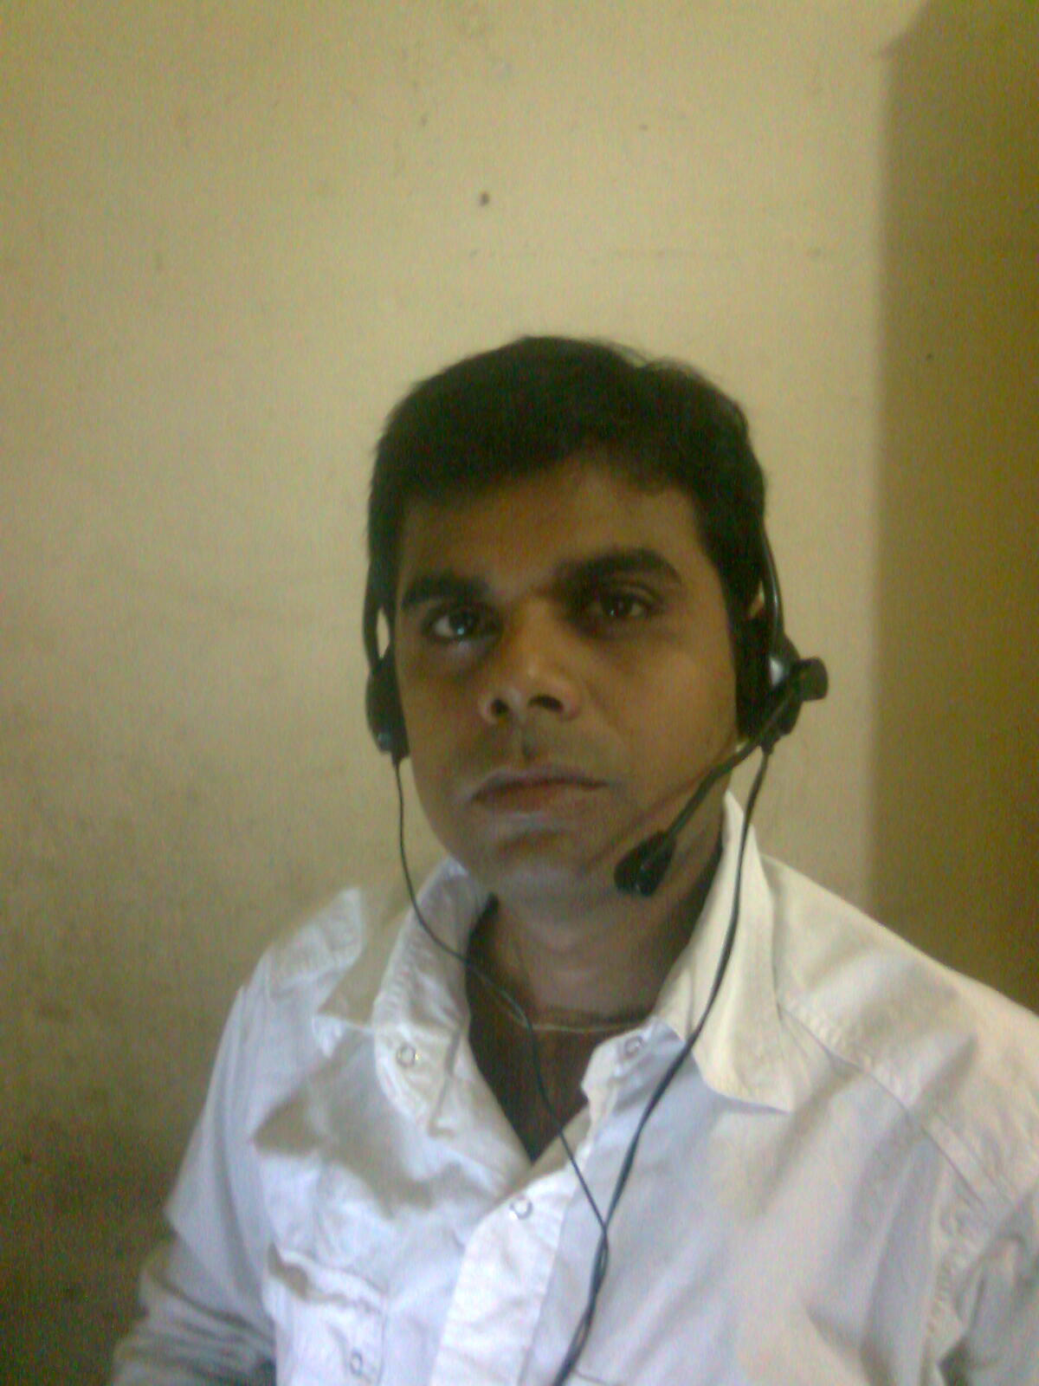
NIKHIL KUMAR
MBA (HR & FINANCE)
nikhilksrivastav@gmail.com
+91-9582136325/9871430029(M)
Career Objective: Seeking challenging career opportunity in HR & Finance field, where my knowledge, experience and skills can be best utilized. I am willing to work as a key player in challenging & creative environment.

PROFESSIONAL PROFILE
- Three & half + year’s experience in HR (Payroll) profile.
- 250+ employees currently handling in India & Overseas(USA & Netherland)
- A qualified MBA in HR & Finance & having a sound academic background in respective field.
- Well versed with modern HR Systems & Procedures and provisions with Companies Act.
- Ability to solve problems quickly, efficiently and "think outside the box".
- Possess a positive attitude and extremely advanced technical skills.
- Experience and ability to teach or instruct co-workers.
- Adept at adopting emerging trends, addressing industry requirements to achieve organizational objectives & profitability norms.
- A keen professional with abilities in mentoring & motivating teams in optimising their contribution levels.
- Good interpersonal skills, resolving employee grievances and conflicts, conducting disciplinary investigations morale boosting of employees.
- Committed to deadlines and quality
- Goal oriented, self-motivated, Hardworking

AREAS OF EXPOSURE

Human Resource Management
- Recruitment & Manpower Planning
- Performance Management
- Compensation & Benefits
- Statutory Compliance
- Employee engagement
- Payroll Processing
- Labour Laws(PF, Bonus, ESI,LWF, Gratuity)
- Induction & Joining formalities
- Employee Grievance Handling
- MIS Reporting
- Taxation / Statutory Compliance(TDS, VAT, Service Tax)

ORGANISATIONAL RECITAL

3. SJM SOFTECH Pvt Ltd. Duration:-10thNov.2011 - till date
Designation Executive HR (Payroll)
SJM SOFTECH Pvt. Ltd. is a software company with offices in Delhi - India which works with clients all around the world. We focus on highly qualitative, timely delivered and cost-effective offshore software development services. With a rich and varied experience in providing offshore software development and project management capabilities and stringent quality standards ensure us to develop solutions that give your business an edge over your competitors. Our global software outsourcing model makes sure we deliver maximum targeted result to you. We don't look for clones. We always say "Keep Learning and Success Will Follow".
Details of Professional Experience in SJM SOFTECH Pvt Ltd.

- Currently handling a team of 5 associates to get the thing done.
- Maintaining HR Database and personnel information, personnel filing system, Providing Reports as required, preparing letters in relation to Probation evaluation, transfer, experience, relieving, no objection etc.
- To analyze, maintain & update the personal & professional profile of the employees for assessment of the same.
- Responsible for all HR related administration activities of the organization.
- Leave management.
- Coordinating the Training process.
- Payroll Processing
- MIS Reporting
- Compensation & Benefits
- Inventory Management
- Bank Reconciliation Statement.

2. RRCA & ASSOCIATES Duration: - 9thApril.2010–31stOct.2011
Designation Executive HR (Payroll)
RRCA & ASSOCIATE incorporated in 2008, is a dynamic accountancy firm with a core focus on Internal and Management Audits. It is a hub of professionals with the aim of providing value added professional services in various fields. We have been providing professional services to, Multinational Companies and Representative/Liaison Offices in India.
Client: - Lanco Power Ltd, BSBK Engineering Pvt. Ltd.
Details of Professional Experience in RRCA & ASSOCIATES
- Payroll Processing
- MIS Reporting
- Compensation & Benefits
- Inventory Management
- Taxation(TDS, VAT, Service Tax)
- Bank Reconciliation Statement.
- Daily Accounting
1. BCC & Co. Duration:- 7th Oct.2009– 31stMarch.2010
Designation: Account Executive
BCC & Co. has been providing quality payroll processing and employee benefits management like Payroll, Statutory compliance, Labour Law etc.

Details of Professional Experience in BCC & Co.

- Daily Accounting, Invoice Generation, MIS Reporting, Taxation(TDS, VAT, Service Tax)Payroll Processing (TDS, PF, ESI, Bonus), Auditing, Petty Cash Handling,
Bank Reconciliation Statement, Inventory Management.
ACADEMIC CREDENTIALS

- MBA (HR & Finance) from PTU in 2012.
- B.Com (A/c Hons.) from Magadh University.

COMPUTER PROFICIENCY

2. Computer Training from APTECH COMPUTER EDUCATION, New Delhi
1. Diploma in computer Application from Sterlite Foundation, Patna

- Operating system known (Windows XP/7 )
- Advanced Knowledge in MS-Office (Word, Excel, PowerPoint)
- Tally (Version 5.4, 6.3, 7.2, ERP 9)
- Basic Internet Concepts.

PERSONAL DETAILS

Father’s Name : Rajdeo Prasad Srivastava

Date of Birth : 21st Feb.1982

ADDRESS : S-89, First Floor (Rented Flat)
Street no. 10
Pandav nagar
New Delhi-92

Marital Status : Single

Gender : Male

Nationality : Indian

Languages Known : Hindi & English

Hobbies : Travelling, Reading, Gardening, Listening Music & to help
Physically challenged Person
Extra Activity : Winner in debate at college level.
Current CTC : 2, 16,000/- p.a
Expected CTC : Negotiable
Notice Period : One Week

Declaration:

I hereby declare that the above-mentioned information is correct up to my knowledge and I bear the responsibility for the correctness of the above-mentioned particulars.

Date: --/--/----

Place: (Nikhil Kumar)

